דף עבודה לולאות

28.

public static void ex28()

{

int count;

Console.WriteLine("start program");

for (count = 1; count < 5; count++)

Console.WriteLine("count = " + count);

}

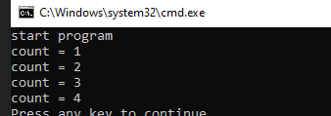

ב.

|  |  |
| --- | --- |
| הפלט של הלולאה | גבולות הלולאה |
|  | (count=-3; count<5; count++) |
|  | (count=7; count<6; count++) |
|  | (count=1; count<1; count++) |

29.

public static void ex29()

{

int i;

for (i = 1; i < 5; i++)

Console.WriteLine("good ");

Console.WriteLine("morning");

}

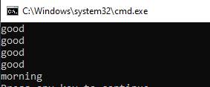

29ב.

public static void ex29()

{

int i;

for (i = 1; i < 5; i++)

{

Console.WriteLine("good ");

Console.WriteLine("morning");

}

}

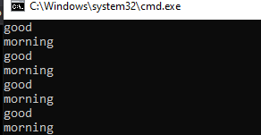

30.

public static void ex30()

{

int i;

for (i = 1; i < 5; i++)

{

Console.WriteLine("Omri Benishay");

Console.WriteLine("Israel");

Console.WriteLine("0547090763");

}

}

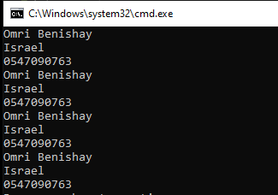

31.

public static void ex31()

{

int count, num;

Console.WriteLine("enter natural number");

num = int.Parse(Console.ReadLine());

for (count = 0; count < num; count++)

{

Console.WriteLine(num);

}

}

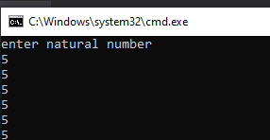

32.

public static void ex32()

{

int num1,num2,newnum;

num1 = 1;

num2 = 1;

newnum = num1 + num2;

for (int count=0; count<4;count++ )

{

Console.WriteLine(num1);

Console.WriteLine(num2);

Console.WriteLine(newnum);

num1 = newnum + num2;

num2 = num1 + newnum;

newnum = num1 + num2;

}

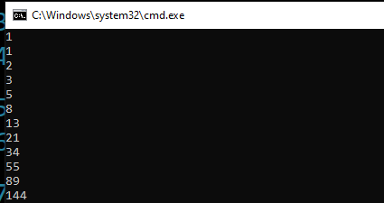

33.

public static void ex33()

{

int snum, bnum, i, num;

Console.WriteLine("Enter the smaller number");

snum=int.Parse(Console.ReadLine());

Console.WriteLine("Enter the bigger number");

bnum=int.Parse(Console.ReadLine());

for(i=snum;i<=bnum;i++)

{

Console.WriteLine(snum);

snum = snum + 1;

}

}

33ב.

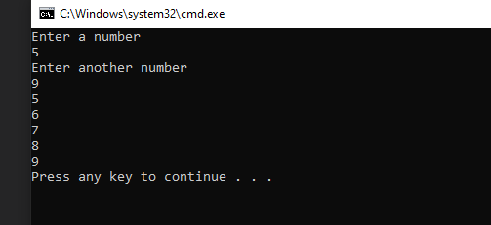

public static void ex33()

{

int snum, bnum, i;

Console.WriteLine("Enter a number");

snum = int.Parse(Console.ReadLine());

Console.WriteLine("Enter another number");

bnum = int.Parse(Console.ReadLine());

if (snum > bnum)

for (i = bnum; i <= snum; i++)

{

Console.WriteLine(i);

}

else

{

for (i = snum; i <= bnum; i++)

{

Console.WriteLine(i);

}

}

}

34.

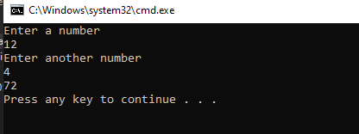

public static void ex34()

{

int num1, num2, i;

Console.WriteLine("Enter a number");

num1 = int.Parse(Console.ReadLine());

Console.WriteLine("Enter another number");

num2 = int.Parse(Console.ReadLine());

int sum = 0;

if (num2 > num1)

{

for (i = num1; i <= num2; i++)

{

sum = sum + i;

}

}

else

{

for (i = num2; i <= num1; i++)

{

sum = sum + i;

}

}

Console.WriteLine(sum);

}

}

37.

public static void ex37()

{

int i, j;

for (i = 1; i <= 10; i++)

{

for (j = 1; j <= 10; j++)

Console.Write("\t" + i * j);

Console.WriteLine("");

}

}

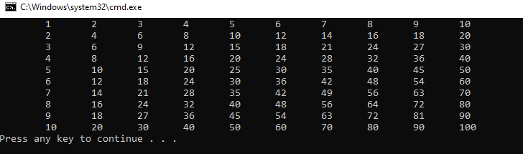

38.

public static void ex38()

{

int i, j;

for (i = 1; i <= 5; i++)

{

Console.Write(i);

for (j = 0; j < i; j++)

Console.Write("x");

Console.WriteLine("");

}

}

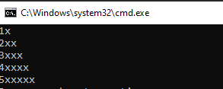

38ב.

public static void ex38bet()

{

int i, j;

for (i = 1; i <= 5; i++)

{

for (j = 1; j <= i; j++)

Console.Write(j);

Console.WriteLine("");

}

}

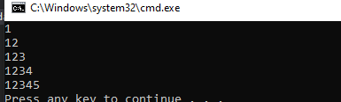

39.

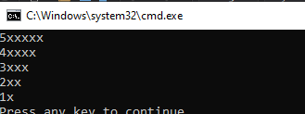

public static void ex39()

{

{

int i, j;

for (i = 5; i >= 1; i--)

{

Console.Write(i);

for (j = 0; j < i; j++)

Console.Write("x");

Console.WriteLine("");

}

}

}